MOUNT SUMMIT CHALLENGE 3.5 MILE RUN/ WALK
SUNDAY, APRIL 26, 2009 AT 9:00 A.M. HOPWOOD, PA
Back by popular demand, the Fayette Striders will host a post-race party including pizza, snacks, and drinks, DJ Chaz, prizes, and awards ceremony! The first 500 registered will also receive a coupon for a free spaghetti dinner to Pasta Lorenzo’s. The proceeds of the race will support the Fayette Striders Cross-Country and/or Track & Field Scholarship fund. Please remember this is a point-to-point race and that transportation after the race is not provided back to Hopwood or the post race party.

Packet Pickup: Registration and Packet Pickup will be between 7:00AM and 8:30 AM at the Hopwood Volunteer Fire Department Station on Route 40 in Hopwood. Participants are encouraged to register and/or pick packets up early on Saturday April 25th, from 4PM to 7PM, at McMillen Engineering Inc., 115 Wayland Smith Drive near Pasta Lorenzo’s, which is across from Uniontown Holiday Inn.

Time/Location: The race starts promptly at 9:00AM on Sunday, April 26, 2009! There is a 1 minute delay for walkers. The post race party and awards ceremony will be at the Uniontown VFW Post 47 from 10 AM till noon.

Results: SERJ Racing Services from Uniontown will provide computerized results which will be posted after the race at the awards ceremony and www.fayettestriders.org .

Runner & Walker Awards: Top 3 Male/ Female overall and top 3 in age group
Age Groups: 14-U; 15-19; 20-29; 30-34; 35-39; 40-44; 45-49; 50-54, 55-59, 60-69, 70-over
Heavyweight (Male Runners ONLY): Top 3 in each division (Cruiser 175-199; Clydesdale 200/over).

Registering as a heavyweight requires weigh-in and forfeits eligibility for age group awards.

Fee: Registration postmarked by April 1, 2009 is $20. Afterwards registration is $25. If you need an XXL shirt, please add $2.00 to the registration fee. $5 will be deducted for any participants of the age 18 and under! Registration includes one party ticket, additional tickets are $2 for pre-registered and $3 after April 1st. Shirts not guaranteed to participates registered after April 1. Make checks payable to Fayette Striders Running Club. There will be a charge of $25.00 for all returned checks. The Club prefers cash or cashier’s check on race day.

Questions: Contact Joe Thomas at 724-438-0628 in the evening or e-mail: officers@fayettestriders.org

Name : |  |  |  |  | Age:
Address: |  |  |  |  | Date of Birth:
City: |  |  |  |  | Phone:
State: |  | Zip: |  | e-mail:
PLEASE CIRCLE ONE!!!
Sex: Female / Male | Shirt size: S M L XL XXL (+$2.00)
Circle One Event: Open/Age Group Cruiser Clydesdale Walker
Race Fee: Registration by April 1, 2009 is $20;  afterwards and race day $25  *Additional $2 for XXL * $5 off if 18 and under |  |  | Number of Additional Party Tickets: ____  Registration by April 1, 2009 is $2; afterwards $3

Mail to: Fayette Striders Running Club, P.O. Box 1441, Uniontown, Pa 15401
In consideration of my entry being accepted in the Mt. Summit Challenge race, I, intending to be legally bound, do hereby, for myself, my heirs, executors, and assigns, waiver, release and forever discharge any and all rights and claims for damages that I may have or which may hereafter accrue to me against the Mt. Summit Challenge, Fayette Striders Running Club, SERJ Racing Services, PennDOT and all sponsors. I understand the difficulty of this event and agree that I am in good physical condition.

Athlete Signature: Date

Signature of Parent/ Guardian if Athlete under 18

Directions to Post Race Party and Awards Ceremony

Turn onto NATIONAL PIKE WEST/ US-40 BR. Continue to follow US-40 BR W
End at Veterans of Foreign Wars: 142 W Main St, Uniontown, PA 15401, US Distance: 2.51 miles

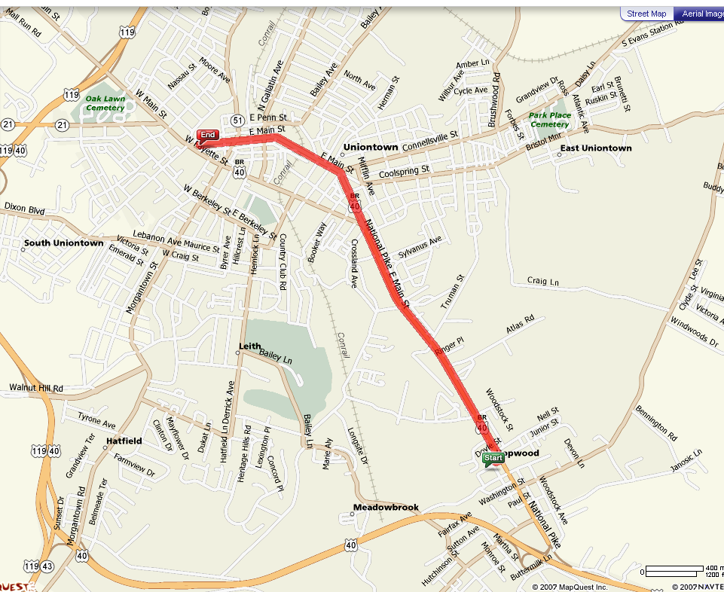

Sponsors: We are pleased to announce our current 2009 sponsors: SERJ Racing Services, First Federal of Greene County Savings and Loan; Pasta Lorenzo, McMillen Engineering, Inc.; and Sports Psychology Services of PA! Additional sponsors to be announced race day.

